ER Diagram
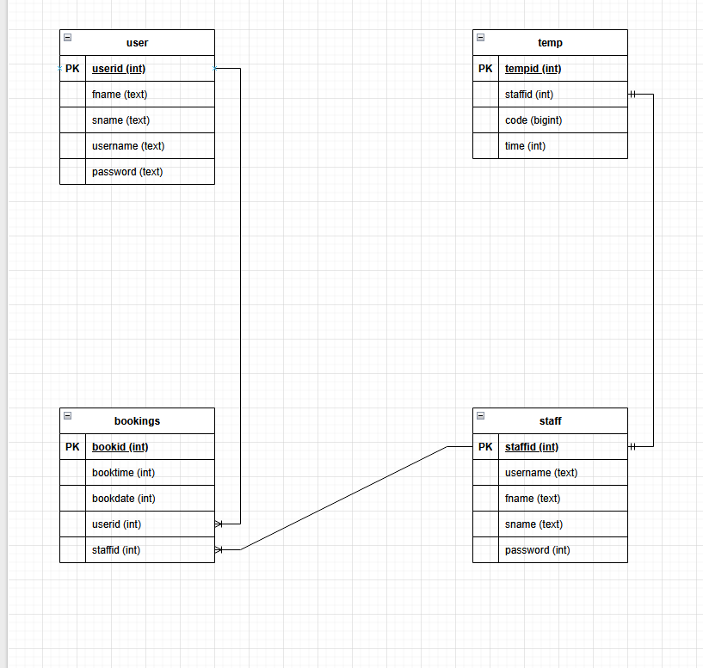

Data Dictionary

Field Name | Data type | Example data | Validation – Just explain how you would validate the data given | Justification

Variable list

Variable name | scope | Data type | Example Data | Where used | Justification
$conn | Local | Database connection object | $stmt = $conn->prepare($sql); | Every page except your index page, or pages that don’t require a connection.

